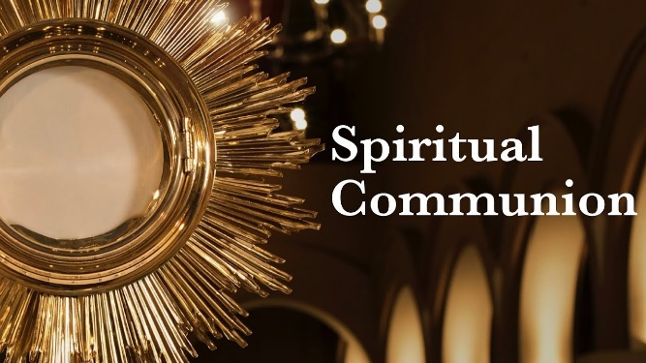
SPIRITUAL COMMUNION

The most perfect way to receive our Lord Jesus is to receive Holy Communion, but there are times, like the present, in which we could be hindered or prevented from receiving the Holy Eucharist. Happily, you can spiritually unite with our Lord Jesus with a Spiritual Communion, which is a classic spiritual practice wonderfully suited to the necessity of cancelling public Masses for the foreseeable future. A Spiritual Communion is a spiritual practice in which you profess your belief in the Real Presence of Jesus in the Holy Eucharist and request Him to enter your soul spiritually.

Saint Thomas Aquinas describes a Spiritual Communion as a holy desire to receive Jesus in the Eucharist, and a loving embrace from Jesus as though you had already received Him. Saint after Saint has recommended this powerfully spiritual practice. St. Catherine of Siena compared it to receiving Jesus from a “silver Chalice” instead of the gold chalice. Pope St. John Paul II strongly recommends the practice of Spiritual Communions in his document Ecclesia de Eucharistia:
“… It is good to cultivate in our hearts a constant desire for the Sacrament of the Eucharist. This was the origin of the practice of “spiritual communion,” which has happily been established in the Church for centuries and recommended by Saints who were masters of the spiritual life. St. Teresa of Jesus wrote: “When you do not receive communion and you do not attend Mass, you can make a spiritual communion, which is a most beneficial practice; by it the love of God will be greatly impressed on you.”” (EE,34)

The basic elements for a Spiritual Communion are as follows:

1. You will want to make sure that your soul is in the state of grace, i.e. with no unforgiven mortal sin. So, start with an Examination of Conscience; there is a thorough one here (http://www.beginningcatholic.com/catholic-examination-of-conscience), a brief one here (https://mycatholic.life/catholic-prayers/examination-of-conscience/), and there are Examinations on the bookrack.

2. Express your belief in the Real Presence of Jesus Christ in the Eucharist: “Jesus, I love You and I believe that You are really present, Body, Blood, Soul, and Divinity in the Holy Eucharist.”

3. Express your inability to receive Jesus Sacramentally in the Eucharist: “Jesus, unfortunately, I cannot receive You Sacramentally in Holy Communion at this time.”

4. Invite Jesus to spiritually enter your soul: “Jesus, I now ask you to enter my soul spiritually”. (followed this with a brief time of silence and receptivity to the spiritual entrance of Jesus into your soul)

5. Offer your thanksgiving: “Jesus, thank You for spiritually entering my soul. I embrace You, I love You, I praise You, and I adore You for Your infinite grace and mercy. Never permit me to be separated from You. Amen.”

NOTE: If you watch Holy Mass on television, make your Spiritual Communion after the “Lamb of God,” when you would normally receive Holy Communion.

